20215244 Nguyễn Đức Thắng

Lab01 Report OOP

2.2.5, Write a program to calculate sum, difference, product, and quotient of 2 double numbers which are entered by users.

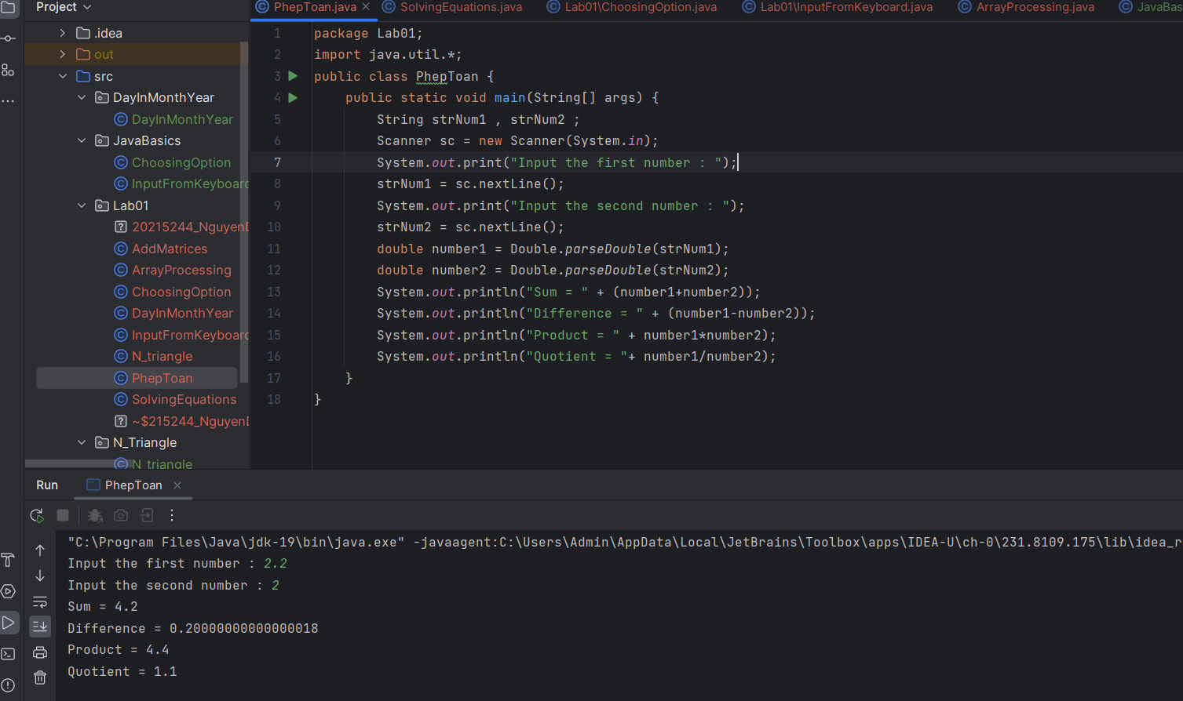

2.2.6, Write a program to solve:

- The first-degree equation (linear equation) with one variable

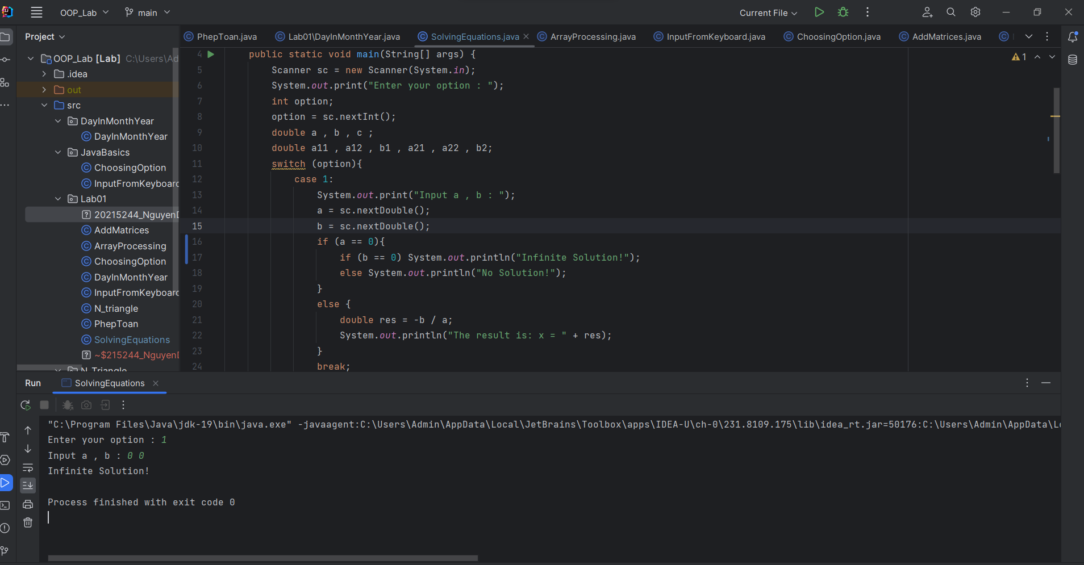

- The system of first-degree equations (linear system) with two variables

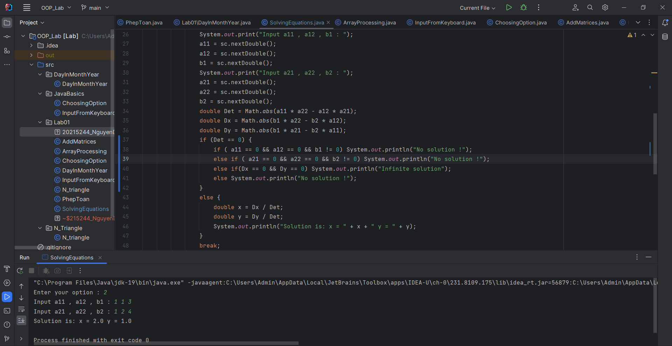

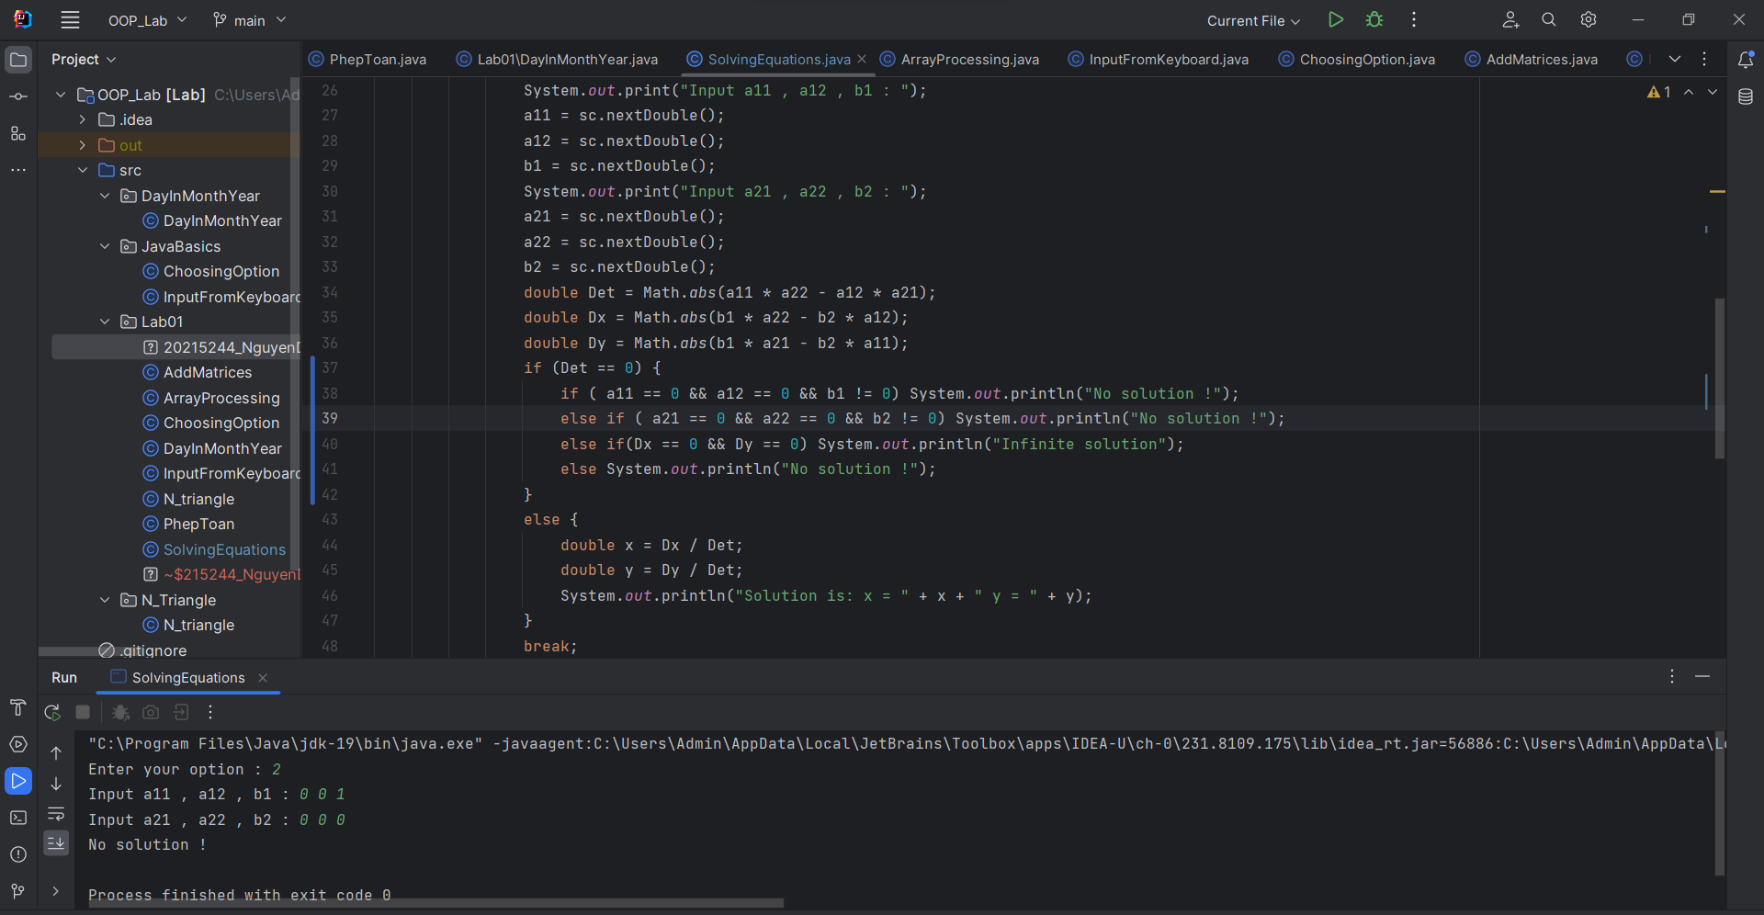

- The second-degree equation with one variable

6.1, Write, compile and run the ChoosingOption program:

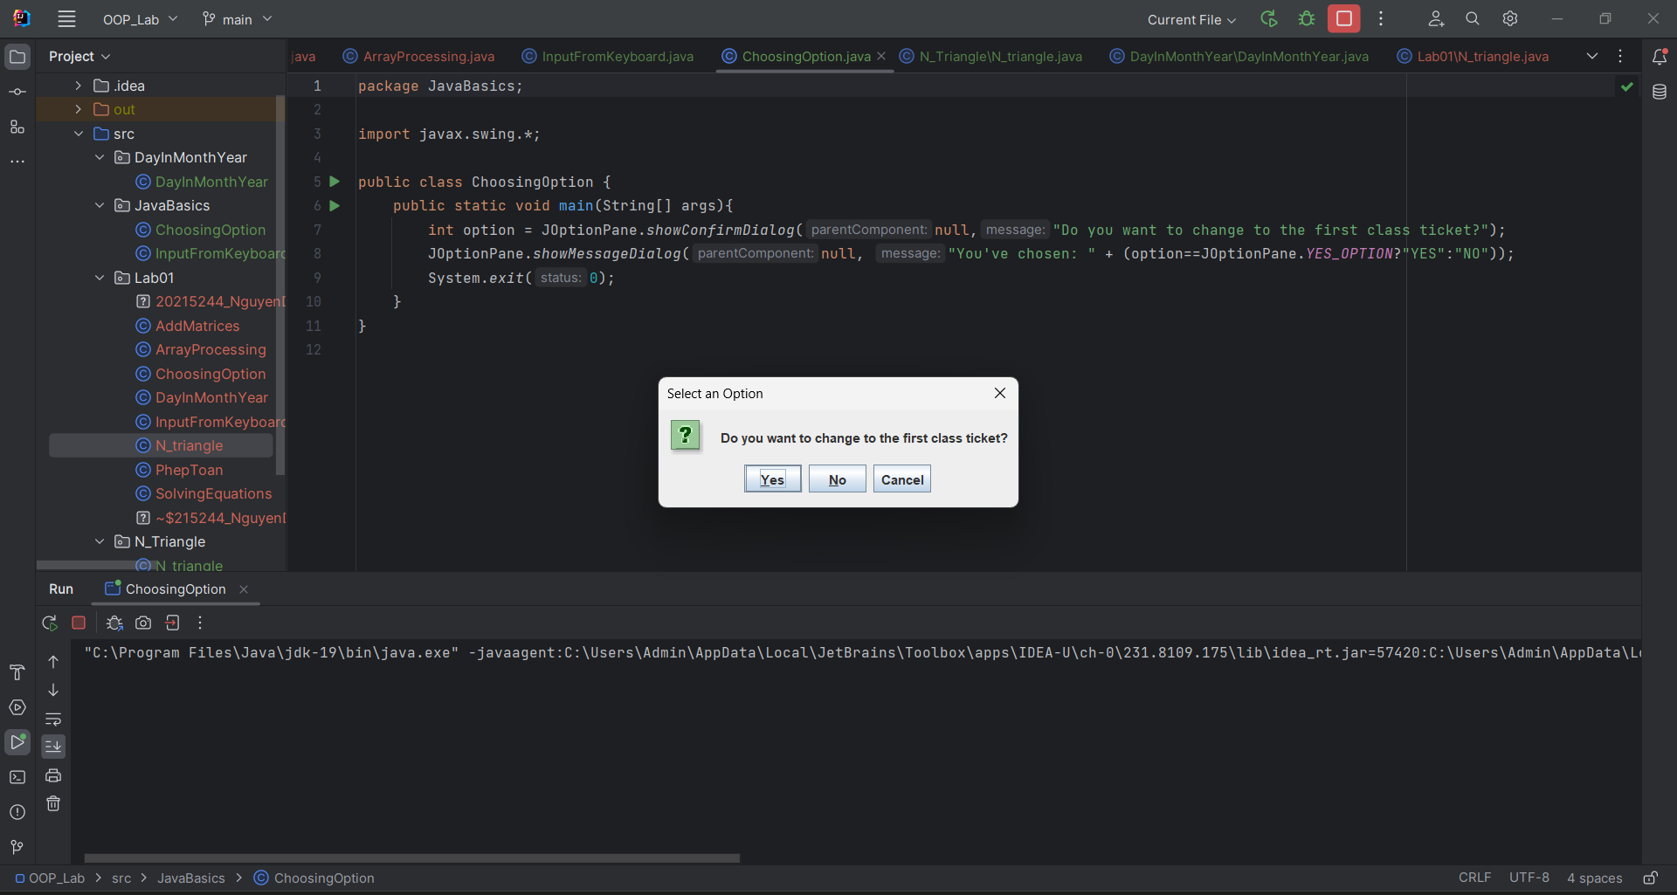

6.2, Write a program for input/output from keyboard

6.3, Write a program to display a triangle with a height of n stars (\*), n is entered by users.

6.4, Write a program to display the number of days of a month, which is entered by users (both month and year). If it is an invalid month/year, ask the user to enter again.

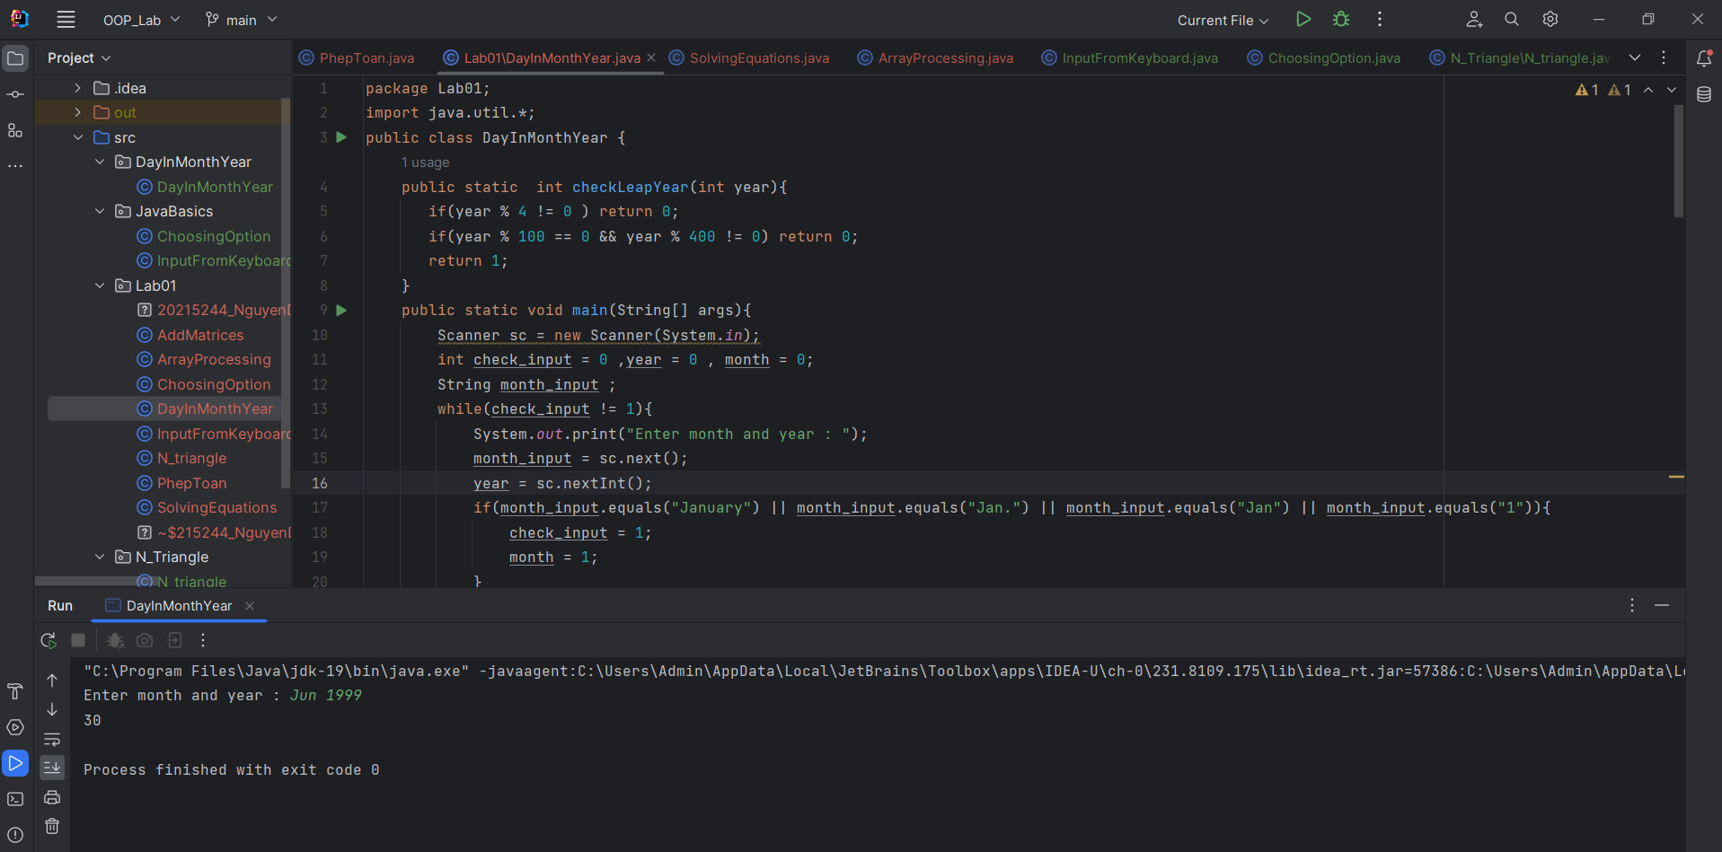

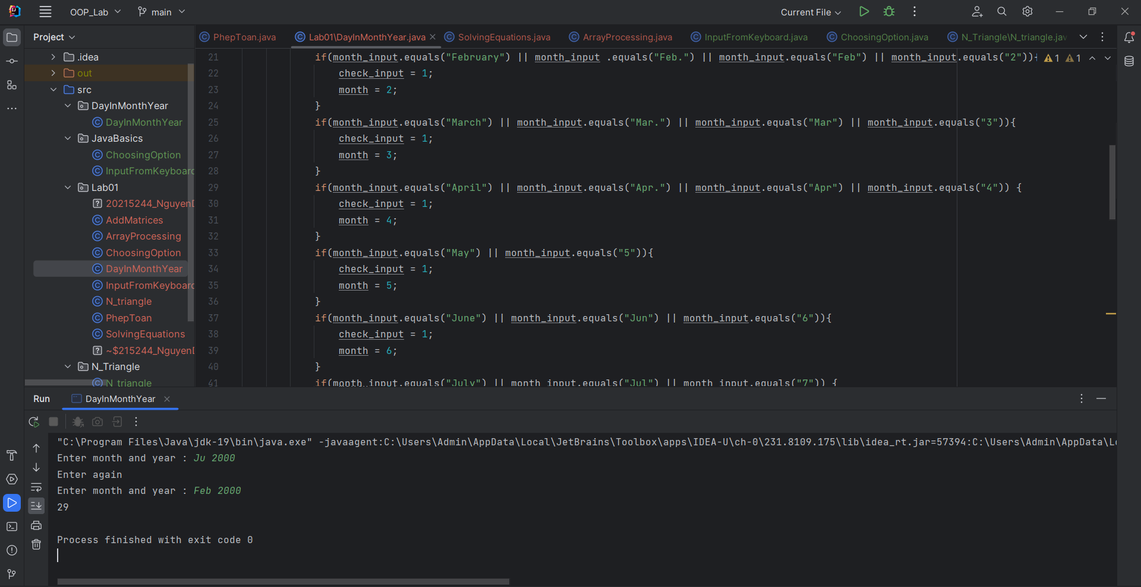

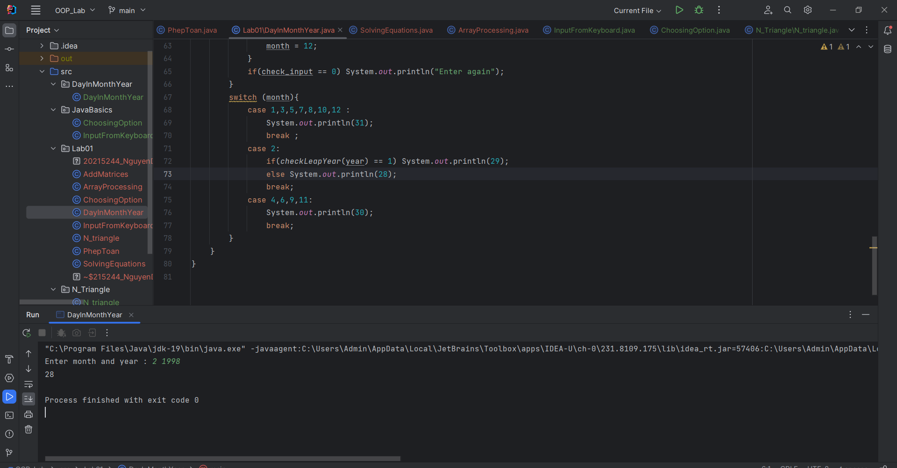

6.5, Write a Java program to sort a numeric array, and calculate the sum and average value of array elements.

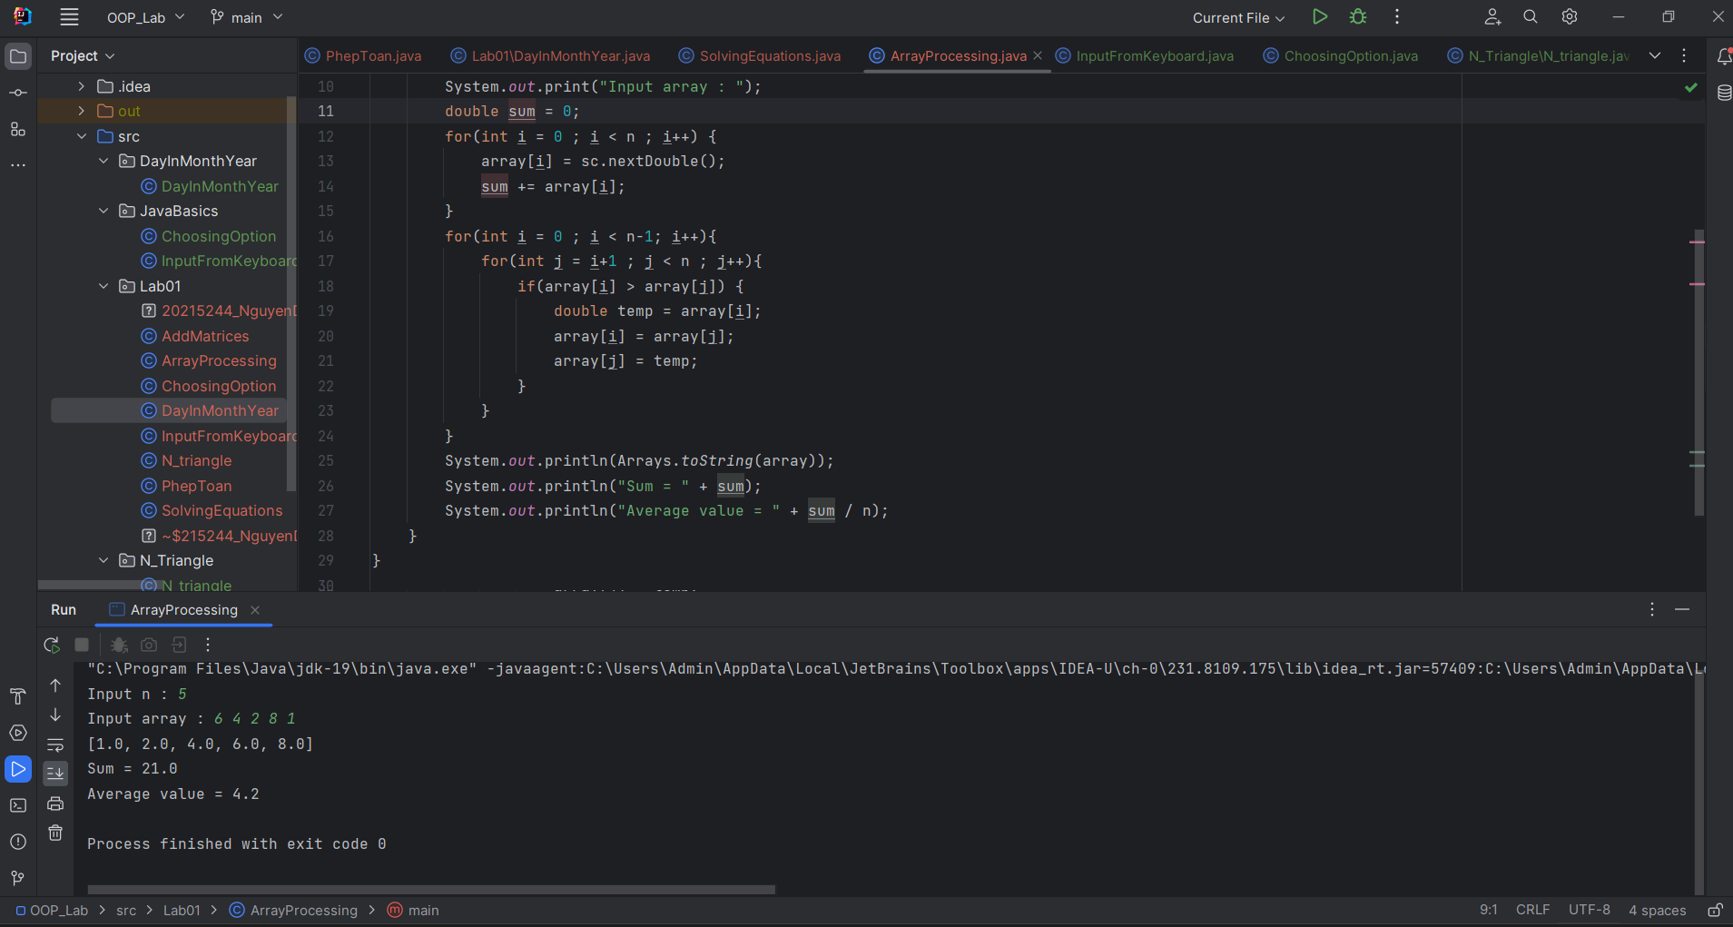

6.6, Write a Java program to add two matrices of the same size.

